Muzzle
What is it?
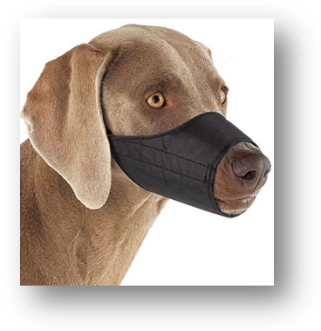 | 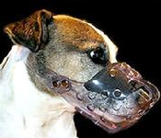 | 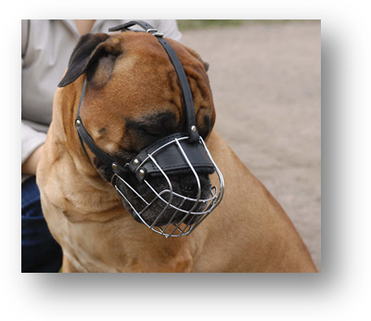
Figure 1 | Figure 2 | Figure 3

Muzzles are typically available as a leather or nylon sleeve, or a basket/cage-style muzzle. The sleeve-style muzzle keeps the mouth closed during brief procedures/examinations (10 minutes or less). The basket-style muzzle covers the entire mouth, yet allows the mouth to open when a dog needs to be muzzled for longer than 10 minutes. Although most dogs still can lick food while wearing a sleeve muzzle, the basket-style muzzle may facilitate food administration, which is especially important during potentially aversive procedures. Center straps provide greater security for brachycephalic breeds ( See arrow in Figure 3).
When should you use it?
We use muzzles for dogs with a history of biting, dogs who are painful, and dogs that display any type of threatening body language. Apply the muzzle BEFORE the dog becomes fearful or reactive, because many dogs perceive the act of muzzling to be threatening . Placing a muzzle on an already fractious dog is challenging and dangerous. In other words, if you THINK you may need a muzzle, use one, and use it early.
How do you safely place a muzzle?
Handlers should have experience with muzzling dogs before attempting to place one on a potentially aggressive dog. There often is a limited window of opportunity to place the muzzle safely, so apply it as swiftly and efficiently as possible.
- Use EARLY
- Make it enticing by smearing food around the inside surface
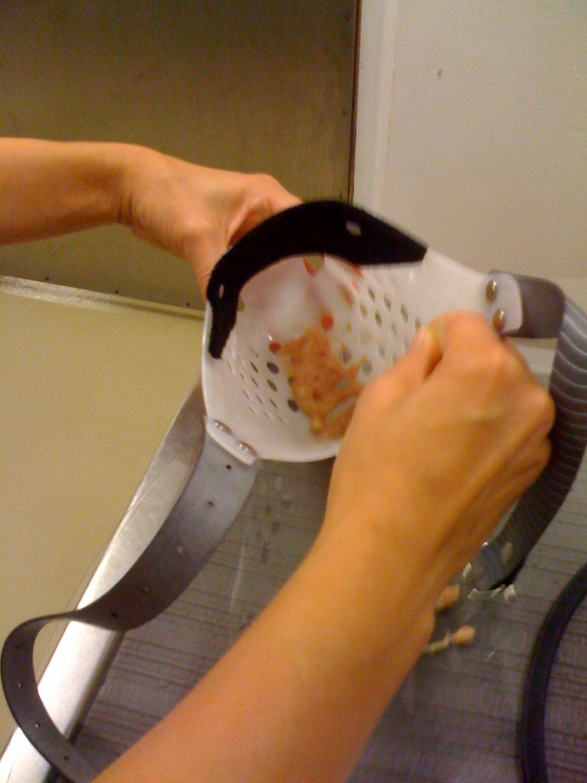
- Place it swiftly and in a non-threatening manner
  - Stand to side of dog
  - Place from behind and from one side
  - Prevent backing up either by having person stand behind the dog, or by backing into a wall or other sturdy surface
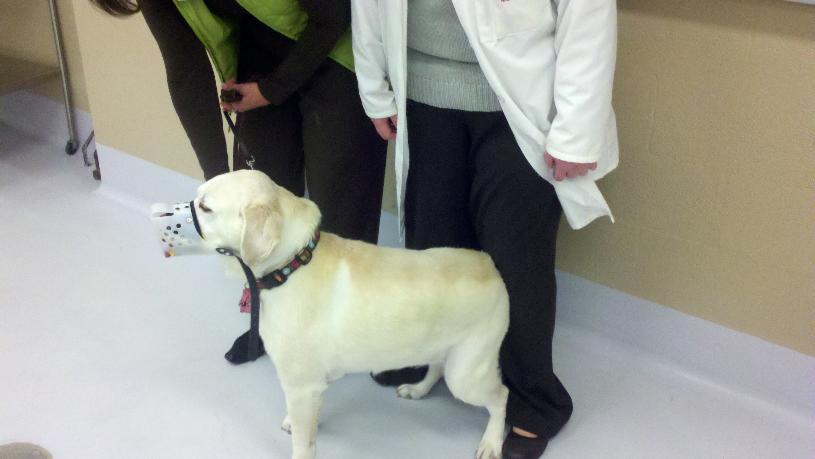
  - Apply quickly and deliberately as you may only have one chance! (have we repeated this enough?)
  - If it is safe to do so, you may consider having the owner muzzle the dog. If you sense any reluctance this is not a good option as there are liability issues here.
  - If the dog has an existing aversion to the sight of a muzzle, a gauze muzzle placed first may be helpful. See below.
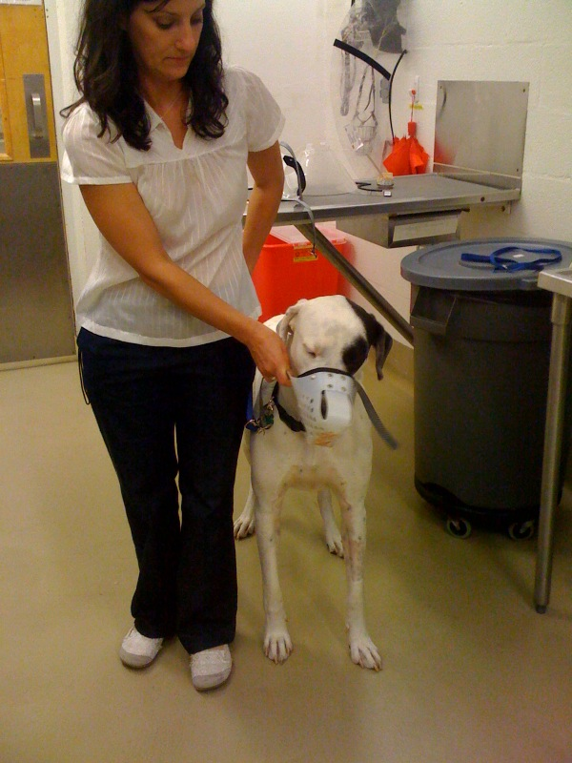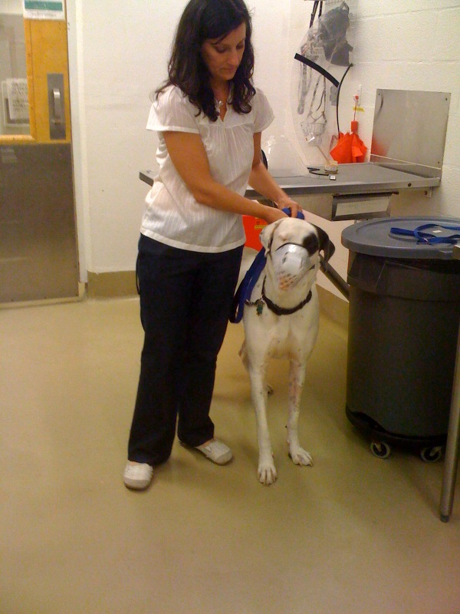
  - Once the muzzle is in place, keep pressure on the straps behind the head to prevent removal should any head shaking or pawing occur
  - It may be helpful to a person put pressure on the muzzle towards the face as you fasten the buckle of the collar as this is a common time for the muzzle to slip off
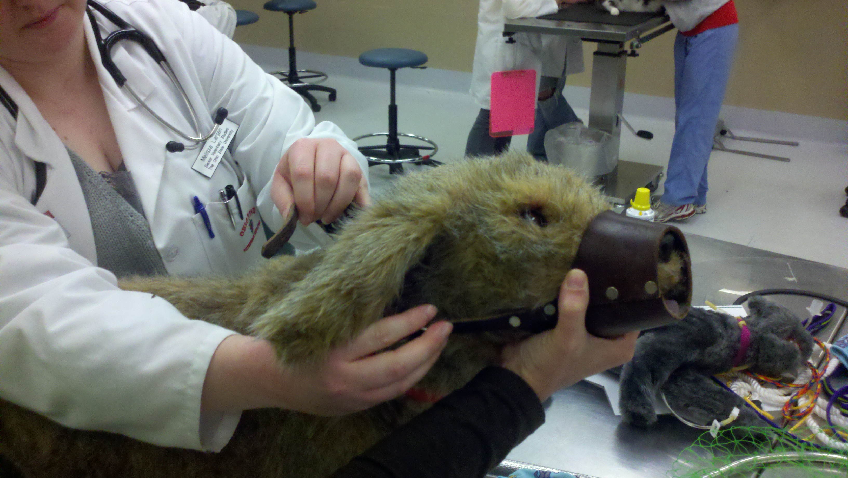

Placing a gauze muzzle:
- Requires skill - practice on friendly dogs!
- Start with a half-throw with the knot on the top of the nose
- Once slipped under chin, pull it tight quickly
- Loop around mouth and tie
- Can then place muzzle on top
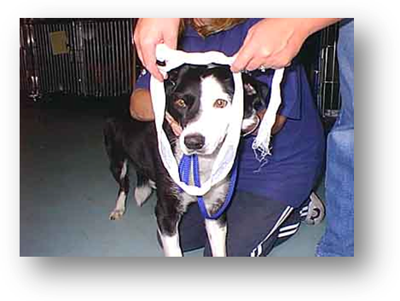
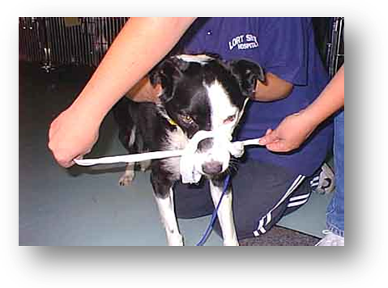
Resources:
www.morrco.com
www.jafco.com
www.petexpertise.com/dog-training-aids/jafco-muzzles.html

