Calming Cap by Thunderworks
What is it?
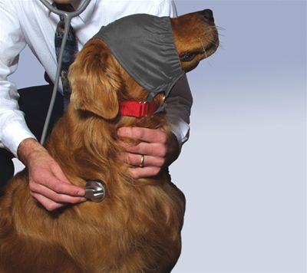
The Calming Cap is a tool we commonly use to ease dogs’ anxiety in high-stress situations. The Calming Cap reduces visual stimuli and helps dogs remain comfortable and feel more secure. The single-panel sheer fabric window filters the dog’s view without blind it. It is available in royal blue, or a light blue print from Premier Pet Products.
When should you use it?
Fearful dogs often accept handling and restraint better when their visual access to stimuli is limited. The cap may also help dogs who are fearful and/or reactive towards unfamiliar dogs in the veterinary setting. Limiting their view of passing and approaching dogs helps them remain calm in a busy lobby or treatment area, and may also help reduce exposure to frightening stimuli when transporting a dog from one area of the hospital to another. Finally, the Calming Cap can be used in addition to placing cotton in the ears to help dogs’ response to injectable sedation by reducing arousing stimuli in the room.
How do you use it?
As when placing a muzzle, stand to the side of the dog and apply the cap from behind and avoid bending directly over the dog when placing the Calming Cap, as many dogs perceive this gesture as threatening.
Placement:
1. Open the short Velcro strap and slide the ring off. Slip the ring and lower collar connectors down between the dog’s neck and his collar. (fig. 1)
2. Firmly fasten the ring back onto the Velcro strap. (fig. 2)
3. Guide the lower collar connectors directly under the dog’s jaw. Slip the elastic portion of the Cap over the dog’s nose and mouth. (fig. 3)
4. Pull the long section of the Cap up over the dog’s head to the back of his neck. Offer food via the front of the Cap (see LSH intro for more information about offering food). (fig. 4)
5. Open the long Velcro strap and slip it under the collar at the back of the neck. (fig. 5)

6. Firmly secure the Velcro. (fig. 6)

The Calming Cap should fit snugly, but not tightly, over the dog’s face with the fabric window positioned over the dog’s eyes.

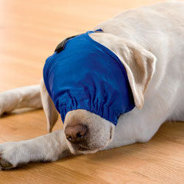
For dogs who need muzzling, place the muzzle before placing the Calming Cap as this product provides no protection from biting. Once the muzzle is securely fastened, you can place the cap over the muzzle and then over the head.
