Adaptil® Dog Appeasing Pheromone
In mammals, all lactating females release substances called "appeasing" pheromones, the function of which is to reassure the offspring. Research has shown that these reassuring properties persist even into the adult stage.
Adaptil® Spray
Adaptil® Spray contains an analogue of the natural canine appeasing pheromone.
It helps comfort puppies and adult dogs in situations they may find worrying or which make them apprehensive.
The spray can be used for events both inside and outside the house, such as:
• Travelling in the car
• Adjusting to a new environment (new home, strangers, shelters)
• Visiting the vet, hospitalization
• Novel & unpredictable situations
Adaptil® Spray helps prevent or reduce fear related reactions expressed as:
• Destruction, inappropriate toileting
• Vocalization (whimpering, whining)
• Salivation
• Vomiting
• Panting
How to use Adaptil® Spray
• Spray 8 to 10 pumps of D.A.P.® 15 minutes prior to expected effects and before the dog is introduced into the environment (car, carrier, kennel etc...).
• Effects should last approximately 1 to 2 hours, although each animal will respond differently.
• Renew application after this time or if you notice a reduced effect.
Adaptil® Spray can be sprayed directly on bedding, inside cages, indoor kennels or in the car. In the house, it can complement the effect of the Adaptil® diffuser where a more local application is required, in kennels, bedding or refuge areas for example.
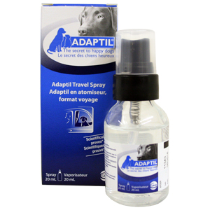
Adaptil® Diffuser
Adaptil® Diffuser contains an analogue of the natural canine appeasing pheromone.
It helps stop or prevent fear related reactions in puppies and adult dogs, expressed as:
• Destruction
• Vocalization
• House soiling
• Excessive licking
Adaptil® diffuser helps comfort puppies and adult dogs in situations they may find worrying or which make them apprehensive (visitors, strangers, vet visits, firework seasons, novel and unpredictable situations).
Adaptil® diffuser helps establish the puppy in a new environment (re-homing, moving house, coping with strangers).
Easy to Use
• 1 diffuser lasts approximately 4 weeks
• Active from 50 to 70 sq.m.
Plug in Adaptil® in the room most used by the dog.
Duration of use may be adapted according to individual needs.
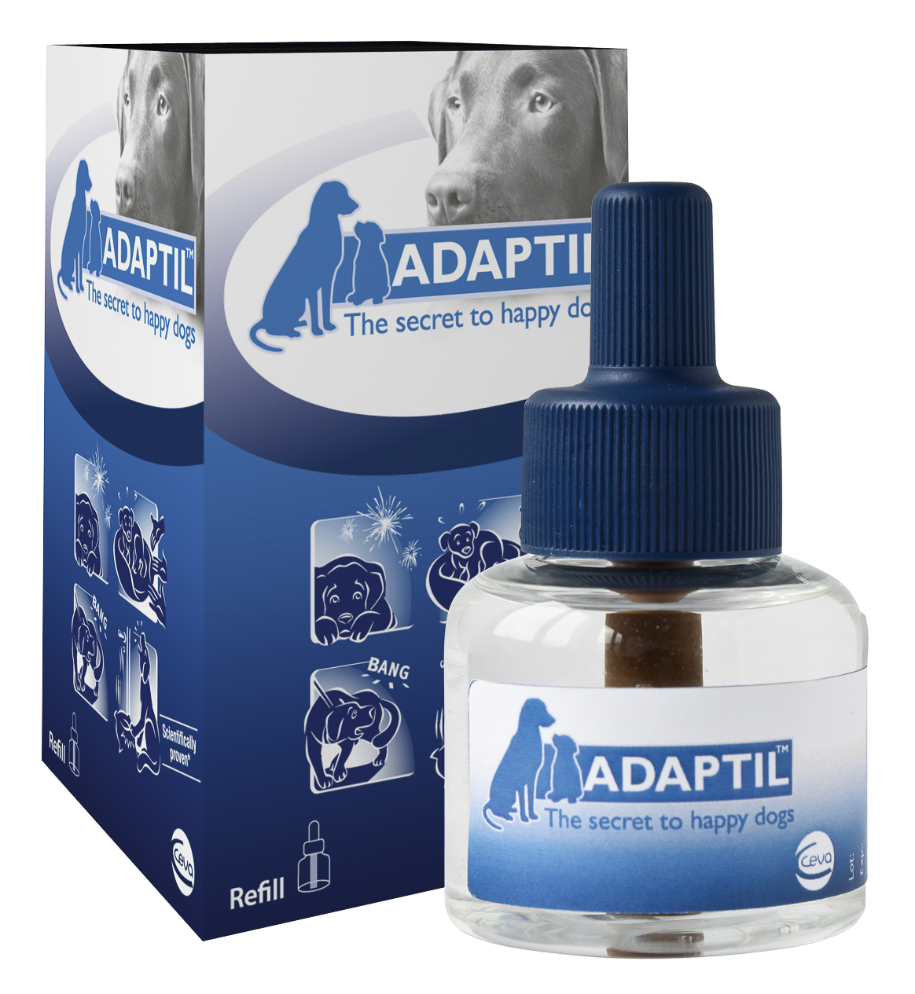
Adaptil® Collar
Canine appeasing pheromone: 2.5%
Excipients q.s. 1 collar: 100%
Uses
The Adaptil® collar will help control or prevent fear related signs in puppies and adult dogs.
It can be used for events happening both inside and outside the home such as:
• Adjusting to a new environment (new home, strangers, kennels)
• Socialization period
• Novel and unpredictable situations
• Fear related reactions expressed outside the home (traffic, other dogs, thunderstorms, gunshots, etc...)
Combining the Adaptil® collar with an Adaptil® diffuser may provide optimal results for dogs showing indoor and outdoor fears.
Directions for Use
Fasten the collar around the dog’s neck and adjust.
Cut off the excess portion of the collar. Leave the collar around the dogs neck at all times.
The effect of the collar lasts up to 4 weeks.
Do not use the collar on dogs with extensive skin lesions
Do not open the protective pouch until the product is ready for use.
Other information
Pheromones are species specific and no effect on pets other than dogs is to be expected.
Adaptil® is not a medication. If there are signs of disease consult your veterinary surgeon.
